
The Grandview Mission Team facilitates on-going relationships between the Grandview family and missionaries/missions that we support as well as emphasizes the importance of missions in general. We host missionaries, plan events, learn about our mission partners, manage the Vision Fund (see below), oversee the Grandview Missions budget, and pray for God’s work around the world.

New team members are welcome. Many opportunities for service are available. Please contact the team leader for more information about joining the team, to request long-term or short-term support, or to receive a current mailing list of our missionaries so that you can send cards and/or packages.

Missions Team Chair: Richard Phillips Email: drrwphillips@gmail.com

Follow this link to read our mission policy: Grandview Christian Church Mission Team Policy

Grandview Mission Partners for 2026

Miles Costello with Canvas, a CMF Globalscope campus ministry in Nottingham, England


Email: gtmcostello6@gmail.com
Canvas Website: www.canvashouse.org/nottingham

Miles has been in England since October 2016 and helped begin Canvas Nottingham. There are more than 60,000 university students in Nottingham. Since then the Canvas community has grown in size and has increased in depth. The Canvas house is open weekly where students are able to come do school work and build community. They have a weekly event where students are able to hear a talk about Jesus and then share their thoughts on the talk. Miles’ weekly responsibilities include writing and giving faith talks, running point on large events (weekend away, Thanksgiving, end of the year banquet), and mentoring students among other responsibilities that arise. Miles and Pip married in Summer 2024! They are expecting their first child in summer 2026!!

Christian Student Fellowship at ETSU in Johnson City, TN

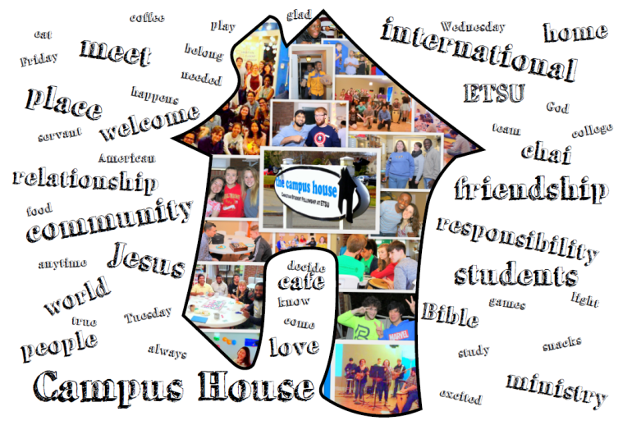

Email: campushouse.etsu@gmail.com
Website: www.campushouse.org/

Work with Christian Student Fellowship reaching out to students at East Tennessee State University (ETSU). The Christian Student Fellowship is a group of men and women committed to knowing our Savior and serving Him as a community on the campus of East Tennessee State University. They do several things each week: free lunch on Tuesday, Immerse (Worship service) on Wednesday, World Café on Friday evenings, and various prayer groups and Bible studies. They provide coffee periodically in campus for ETSU students. Andrew Lawhead is the Director. The leadership team is known as the “Pine Cones.”

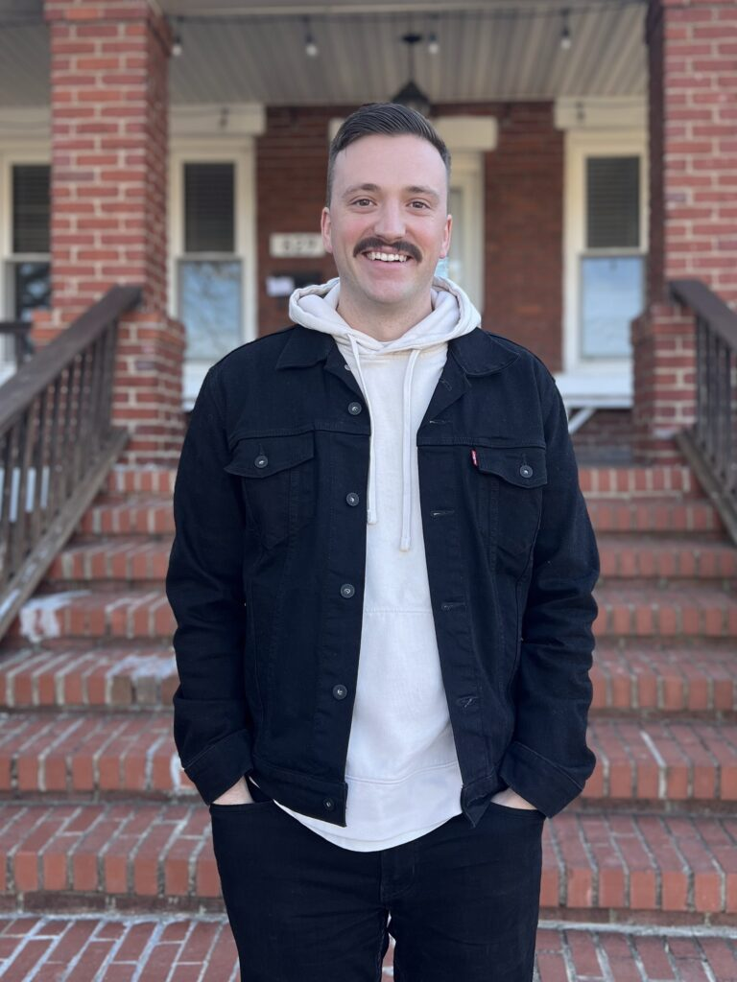

Dennis & Fabienne Freeland with JAARS back in the US

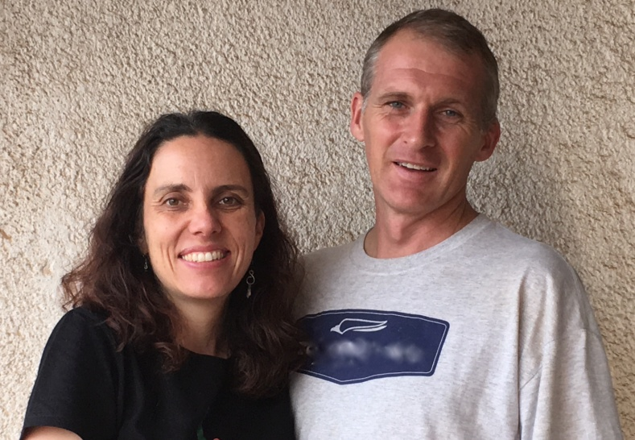

Email: denfree@gmail.com
Email: fffreeland@gmail.com

After many years served in Cameroon, the Freelands are back in the US for a while working with JAARS, the avionics branch of Wycliffe Bible Translators. Fabienne currently serves as an instructor for new missionaries and leads focus groups for JAARS in Michigan, North Carolina as well as other locations as needed. Dennis serves as a pilot instructor, mechanic instructor and leads the logistics team for JAARS.

Meredith McKinney with Roots, a CMF Globalscope campus ministry in Edinburgh, Scotland

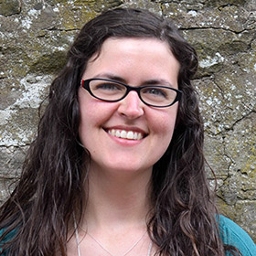

Email: mermckinney@gmail.com
Website: rootsedinburgh.org.uk/
Support Meredith

Meredith is in her ninth school year of ministry with CMF Globalscope’s International Campus Ministry team in Edinburgh, Scotland. Roots is a grace-driven community for all university students. The Roots team strives to inspire students to grow closer to Jesus by living life together in the context of a community. Meredith mentors students, is in charge of the Roots finances, gives talks at the weekly event Tuesday Nights with Roots, and keeps the Roots campus house stocked with tea and coffee. Recently, they have been developing a relationship with the university’s campus chaplain’s office.

Emmanuel Christian Seminary at Milligan in northeastern TN

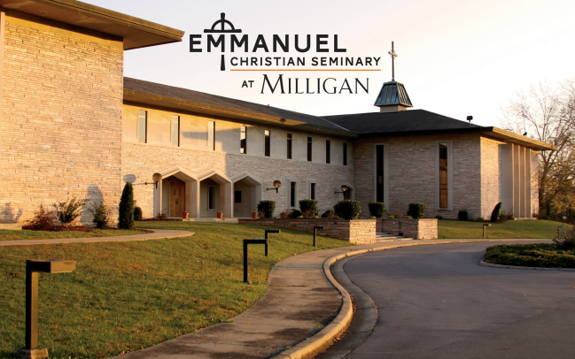

Email: RNSmith@milligan.edu
Website: ecs.milligan.edu

Emmanuel Christian Seminary at Milligan University is a graduate seminary which seeks to fulfill the mission of the Church by preparing men and women for effective ministry. For over fifty years, Emmanuel graduates have gone on to serve in a variety of ministries, including preaching, pastoral care, Christian education, campus ministry, hospital and military chaplaincy, church planting, cross-cultural missions and a host of other ministries. Several professors are members at Grandview.

Milligan University in northeastern TN

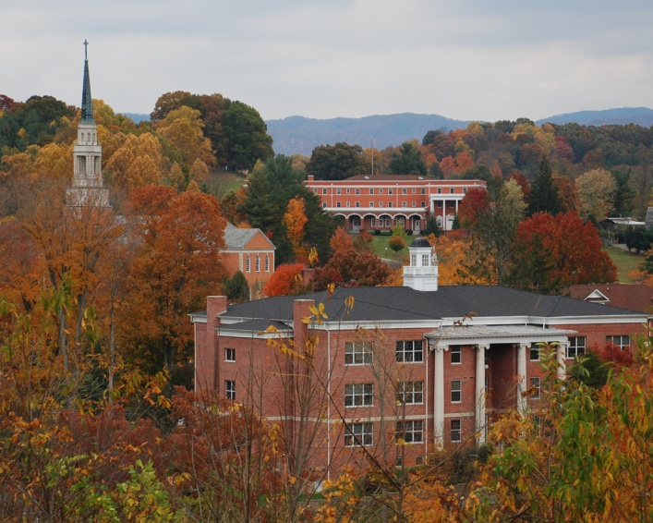

Email: RNSmith@milligan.edu
Website: www.milligan.edu

For more than 150 years, Milligan has been dedicated to educating men and women to lead and to serve. The commitment to Christ-centered education has led Milligan to become a growing, well-respected university. Because of the emphasis on scholarship, community, and faith, students come from all over the world to experience a distinctively different approach to higher education. Milligan has recently added programs in Physician’s Assistants, Engineering, Occupational Therapy and Engineering. At a time when most colleges and universities are struggling to minimize decreases in enrollment, Milligan’s enrollment is increasing, and the quality of incoming students is ever-increasing. Milligan has sent people into the Mission field consistently. Nearly all of our Mission teams we support were at Milligan, Emmanuel Christian Seminary at Milligan University or both. Many members of Grandview have bee students and/or professors and staff at these outstanding academic institutions. Milligan consistently ranks high in value as described by US World and News Report.

Wisdom Nyador and Enoch Nyador with Ghana Christian Mission in Ghana

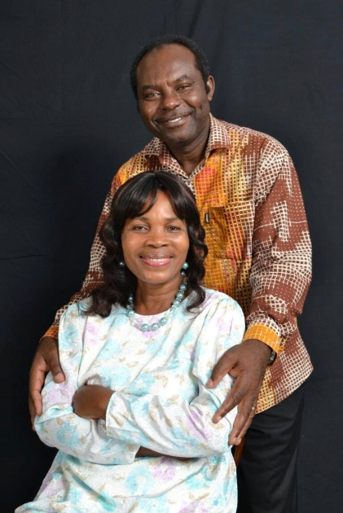
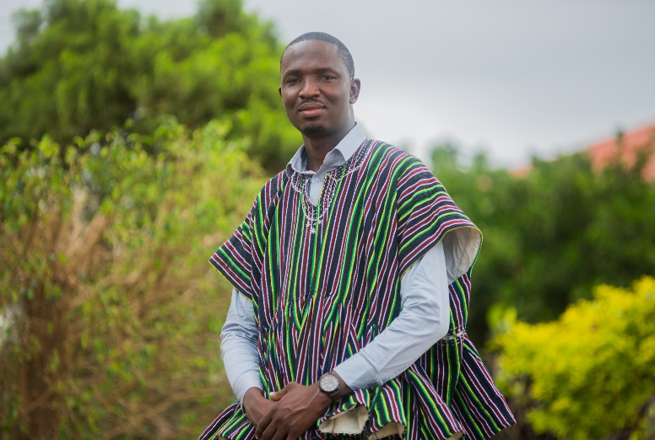
Email: Wisedhomme@gmail.com
Email: enochnyador@yahoo.com
Website: www.ghanachristianmission.com

Enoch began the work over 30 years ago. Enoch lives near Accra, however, the work of GCM stretches all over Ghana. Tragically, Lydia was a victim of cancer in early 2026. Prayers for Enoch and his family as they mourn the loss of a wonderful woman and physician, while praising God that she is with him now. Wisdom Nyador became the Executive Director in 2023. The Four Pillars of Ghana Christian Mission are Church Planting, Medical Outreach, K-12 Education, and Community Outreach / Development. They have planted over 200 churches and have had thousands of baptisms.

______________________________________________________________________
David & Claudia Ossa with La Ruta, a CMF Globalscope campus ministry in Montevideo, Uruguay

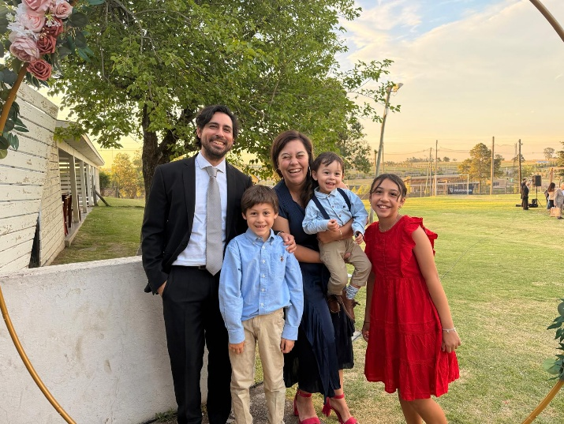

Email: DavidOssa@cmfi.org
Email: Claudia.gonzrub@gmail.com
Website: www.larutamvd.com
cmfi.org/explore/where-we-work/Uruguay

David & Claudia are originally from Chile. They arrived in Uruguay in September 2015 to launch La Ruta, a pioneer campus ministry in the capital city of Montevideo. They work alongside three other teammates. They bought a campus house for their ministry, providing a place where students can be impacted by God’s love through experiencing a loving Christian Community. Their family includes David, Claudia, Emma, Samuel and Lucas. They have also made some exploration trips for Globalscope.

Warren & Julie Veal with Mission Aviation Fellowship (MAF) in various places

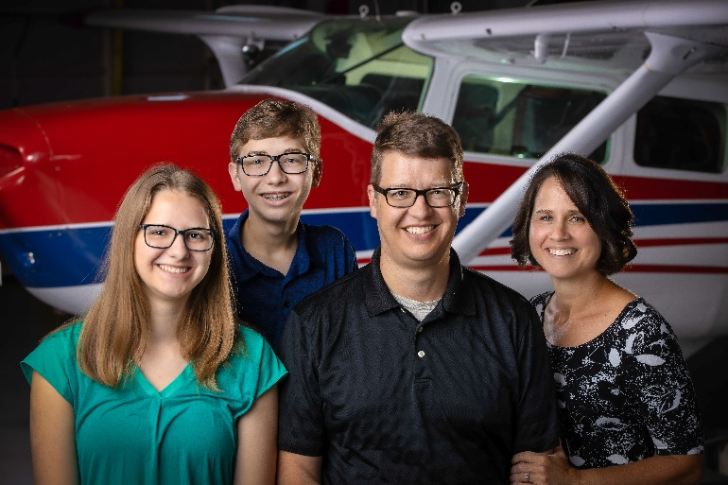

Email: wveal@maf.org
Email: jveal@maf.org
Website: maf.org/veal

Warren and Julie work with Mission Aviation Fellowship’s home office in Nampa, ID after many years in Mozambique where Warren served as a pilot and mechanic. Those years of experience on the field enable Warren to lead the Aviation Maintenance Support Department in maintaining MAFs fleet of aircraft. This ensures that MAFs missionaries can continue to carry out the mission of sharing the love of Jesus with isolated people. He restores aircraft for the pilots to use in the field,

Travis & Emily Weeks with Christian Missionary Fellowship (CMF) in Addis Ababa, Ethiopia

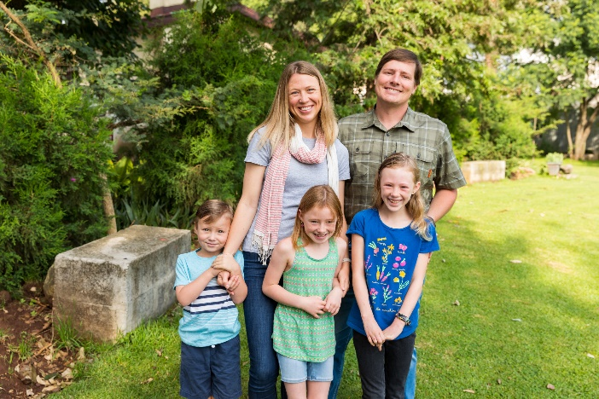

Email: teweeks@cmfmissionary.org
Email: Emily.A.Weeks@gmail.com
Website: give.cmfi.org/p-195-travis-and-emily-weeks.aspx

In October 2013, Travis and Emily joined the CMF church-planting team in Ethiopia. They were located in the city of Nekempte and partnered with the local Kristos Andinet Church (KAC). They are now located more centrally in Addis Ababa, making it more possible for ministers to attend training while avoiding areas of conflict throughout the region. Travis and his team train national church planters to take the gospel into unreached areas of Ethiopia. They have been constructing their training facility which includes classrooms and housing. Travis served as Missionary-in- at Milligan University in the fall of 2025. At the same time, Emily completed her degree in counseling and is now using her skills in Addis Ababa. It was great to have them worshipping with us again at Grandview. Their children are Clare, Jude and Charlie.

_____________________________________________________________________________________

Joe and Marie Lieway with Planting Seeds Ministry, Liberia
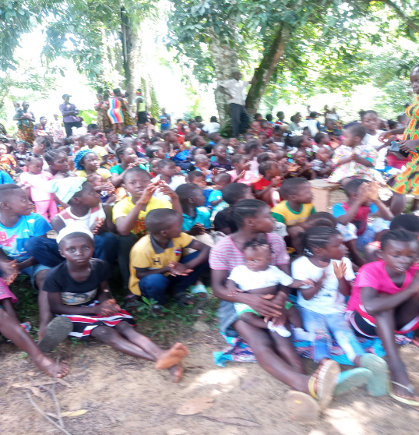

For several years, Grandview has helped with expenses for Joe and Marie to travel to their homeland, Liberia, where they were working to plant churches, train ministers and conduct Vacation Bible Schools. In 2025, the Lieways relocated to full time mission work there. Besides planting churches, sharing the gospel to those who have not heard and educating leaders, they are building a facility that will serve as classrooms, dorm rooms, kitchen and dining area. Several of the churches they helped to plant are working with them to complete this project. We are now providing additional support for their full-time efforts. Recently, they held a conference at the Buchanan Church with over 100 in attendance each day. One of the speakers via teleconference was our senior minister, Aaron Wymer.

Email: Boevahn2@gmail.com
FaceBook: Joe.Lieway.92

Dr. Kip Elolia with Eldoret Institute in Eldoret, Kenya

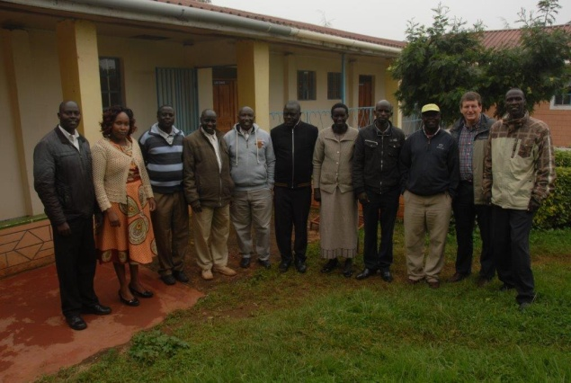

Email: skelolia@milligan.edu

Dr. Kip Elolia oversees administration and teaching at Eldoret Institute, a Bible training school for Kenyan pastors. He has worked with this Bible Institute since 2008. Dr. Elolia travels to Kenya most summers to teach seminary level classes for Kenyan pastors. We have provided books and try to help with part of Kip’s expenses as we are able.

Abigail Haagen with CMF Marketplace Ministries
The CMF Marketplace Ministries team in Mexico City is serving with and provides business courses to entrepreneurs with the goal of economic transformation. When entrepreneurs grow their businesses and lead the marketplace with Kingdom values, it benefits their entire communities. Abigail began by studying Spanish language and culture before she began her active work with Marketplace Ministries. Pictured here in the “Send-off” celebration and prayer on her last Sunday at Grandview before leaving. She was on a short term ministry initially, to see if this was what she wanted to do with her life. She knew shortly than she was ready to serve full time. She is currently raising support so she can return to full time ministry.
