Grandview Christian Church
Cityview Campus Minister
Job Description

ROLE SUMMARY

The role of the Cityview Campus Minister is to oversee the life and direction of the Cityview campus of Grandview Christian Church, as defined by Grandview leadership. This will require a firm grasp of Grandview’s beliefs, values, vision, and mission, as well as the ability to communicate and implement those at a practical level at the Cityview campus.

QUALIFICATIONS
- Be willing to join Grandview as a member
- Be a growing and committed disciple of Jesus
- Have a seminary degree or equivalent (strongly preferred)
- Alignment with Stone-Campbell values as embodied by Grandview
- Have two years minimum prior experience in church leadership
- Be ordained and able to produce a certificate of ordination, or be willing to submit to Grandview’s ordination process
- Possess strong leadership, organizational, and recruitment skills
- Display effective teaching and preaching skills
- Display a caring and approachable attitude about the church and her ministry
- Be evangelistic in ministry approach
- Be relationship and team oriented, with experience in recruiting and building effective teams and identifying competent leaders
- Demonstrate a commitment to excellence
- Work with, and under, the authority of the leadership as outlined in Grandview’s Organizational Chart
- Live a life of integrity, which flows from Gospel transformation

RESPONSIBILITIES
- Focus this campus on the Gospel of Jesus Christ and the mission of Grandview as the church
- Communicate and implement the vision for Grandview Christian Church as defined by the elders, under the direction of the Senior Minister and in cooperation with staff
- Prepare and preach sermons based on the scriptures and themes determined by the preaching team (This typically includes the Senior Minister and Campus Minister and others chosen to be a part of that process)
- Administration of baptism, weddings, funerals, etc. as needed
- Recruit, train, and equip a ministry team composed of paid staff and volunteers to provide leadership and growth of identified ministry areas, including involvement with hiring, termination, and performance appraisal in cooperation with the Executive Minister
- Seek to establish a personal and congregational presence in Downtown Johnson City
- Encourage discipleship and growth through the creation and support of small group involvement, in conjunction with the Discipleship Minister and the Discipleship Team
- Equip the church to share faith in word and deed
- Assist with the preparation of annual budgeting and proactively maintain accountability for expenditures and alignment with budget objectives
- Participate in weekly staff meetings, monthly elders meetings, and other meetings as necessary
- Plan and lead regularly scheduled Cityview staff meetings
- Provide the leading role for pastoral care for the staff, volunteers, and attenders of Cityview
- Handle additional responsibilities as assigned

RELATIONSHIPS
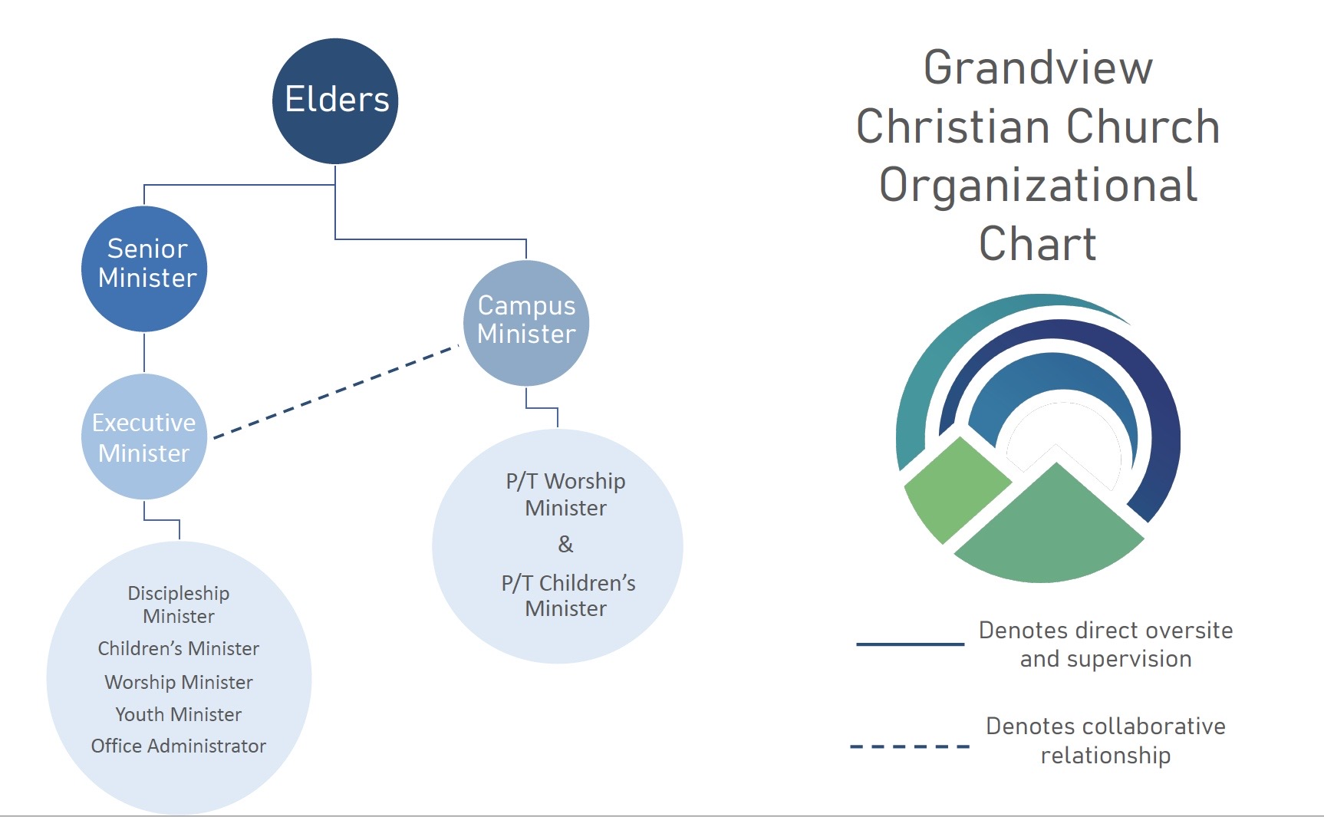

POSITION DETAILS
Position Type: Full-Time (40+ hours)
PTO: Paid major holidays, plus 15 PTO days (sick leave and vacation) during the first year
Compensation details available upon request

For more details, or to apply, please contact Heather Lawson (Grandview Executive Minister) at heather@grandviewchristian.org or 423-928-7866. All applicants should submit a resume, cover letter, and three references.

